Dynamic Metrics for Object Oriented Designs
Sherif Yacoub, Tom Robinson, and Hany H. Ammar
Computer Science and Electrical Eng. Dept.,
West Virginia University
Morgantown, WV26506
+1 304 293 0405 x {2537,2537,2514}
yacoub@csee.wvu.edu, TRobinson@lcsys.com, hammar@wvu.edu

Abstract
As object oriented analysis and design techniques become widely used, the demand on assessing the quality of object-oriented designs substantially increases. Recently, there has been much research effort to develop and empirically validate metrics for OO design quality. Complexity, coupling, and cohesion have received a considerable interest in the field. Despite the rich body of research and practice in developing design quality metrics, there has been less emphasis on dynamic metrics for object-oriented designs. The complex dynamic behavior of many real-time applications motivates a shift in interest from traditional static metrics to dynamic metrics.
This paper addresses the problem of measuring the quality of object-oriented designs using dynamic metrics. We present a metrics suite to measure the quality of designs at an early development phase. The suite consists of metrics for dynamic complexity and object coupling based on execution scenarios. The proposed measures are obtained from executable design models. We apply the dynamic metrics to assess the quality of a "Pacemaker" application. Results from the case study are used to compare static metrics to the proposed dynamic metrics and hence identify the need for empirical studies to explore the dependency of design quality on each.
Keywords: Dynamic Metrics, Design Quality, Object-Oriented Designs, and Real-Time OO Modeling

Introduction
Object-oriented technology is gaining substantial interest as a beneficial paradigm for developing software applications. To evaluate the quality of OO software, we need to assess and analyze its design and implementation using appropriate metrics and evaluation techniques. As a result, several quality metrics have been introduced to measure the application quality at various development phases. Assessing the application quality at an early development phase is beneficial in guiding the development effort at subsequent phases. In this paper, we are concerned with metrics that are applicable at the design phase.
Several approaches have evolved to model OO designs. The Unified Modeling Language [UML99] is the result of the unification process of earlier OO models and notations. UML models capture the application static and dynamic aspects, but do not provide dynamic model execution or simulation. The Real-Time Object Oriented Modeling (ROOM) [Selic+94] was introduced to study the dynamic aspects of applications constructed as concurrently executing objects. ROOM design models support simulation of the application execution scenarios.
The metrics proposed in this paper are based on executable OO design models from which the dynamic behavior of applications can be inferred. The importance of evaluating the run time structure at the design level is recently pointed out by Gamma et.al. [Gamma+95, pp23] "The system's run-time structure must be imposed more by the designer than the language. The relationship between objects must be designed with great care, because they determine how good or bad the run-time structure is". The excess effort in developing executable designs is justifiable for many complex real-time applications. These applications are usually modeled as executable designs prior to deployment in a working environment. Executable models are used to simulate real time applications and deduce their real-time properties such as deadlines and scheduling. The same models can be used to analyze the quality and criticality of objects prior to detailed implementation.
A quality metric should relate to external quality attribute of a design [Hitz+95b]. External attributes include maintainability, reusability, error-proneness, and understandability. Based on observations and empirical studies, coupling [Briand+98] and complexity [Munson+96] were shown to have a direct impact on software quality. As a result, we focus on coupling and complexity metrics. We identify a set of new dynamic metrics and discuss their relationship quality attributes.

Static and Dynamic
Several literatures have defined metrics for object oriented design quality. Design metrics can be classified into two categories: Static and Dynamic. To distinguish static and dynamic metrics, consider the two cases discussed by Hitz et.al. [Hitz+95b], 1) class c₁ invokes a method m of class c₂ 10 times, and 2) class c₁ invokes 10 methods in 10 different classes, once each.
The first case measures the “number of method invocations” while the second measures the “number of methods invoked”. Briand et.al.[Briand+99] identifies the second case as a common metric and using the first metric would “distort the value of the measure”. In this paper, we distinguish the first case as a dynamic metric of designs that can be used to identify critical components.
The dynamic aspects of design quality are less frequently discussed in OO quality metrics literature as compared to static metrics. The distinction between class level coupling (CLC) and object level coupling (OLC) was first made in [Hitz+95a]. The Coupling Between Object classes (CBO) metric cannot be considered an object level coupling because "for object level coupling it is not sufficient to know how many invocations from one method to another, but how often these invocations will be executed at run time."[Briand+99]. CBO [Chidamber+94] was defined as coupling between object classes and cannot be considered coupling between instantiated objects.
Currently, to the best of our knowledge, there is no literature available on object level coupling and dynamic metrics. Briand et.al.[Briand+99] surveyed current literature on coupling metrics and concluded that "All measures are defined to measure class-level coupling. No measure of object level coupling has been proposed." The authors further attributed this result to the difficulty in measuring coupling between individual objects. "One way to measure coupling between objects would be to instrument the source code to log all occurrences of object instantiations, deletion, method invocations, and direct reference to attributes while the system is executing However, this kind of measurement can only be performed very late in the development process." In this paper, we define dynamic metrics that are obtained at an early development phase from executable design models such as ROOM models prior to detailed implementation phases.

Motivation
- Distinguish static and dynamic metrics by differentiating between measuring what is actually happening (dynamic) rather than what should happen (static).
- Augment existing static metrics with new dynamic metrics that evaluate run-time properties of object-oriented applications.
- Assess the run-time quality of object oriented applications at the design level using executable design models instead of implementation phase assessment using source code.
- Active objects are sources of errors because they execute more frequent and experience numerous state changes that translate to attribute modifications and method invocations. Hence, we are motivated to assess the dynamic complexity of objects as expected at run-time.

Contributions
A recent study on coupling metrics surveyed coupling literature in OO systems and concluded that no measures for object level coupling are currently available [Briand+99]. This was attributed to difficulties in measuring coupling between individual objects. We perceive that given advances in object oriented modeling and simulation tools, we are able to evaluate object coupling and complexity from executable designs, which gives early measures of the design quality.
In this paper, we define a set of dynamic metrics for object coupling and dynamic complexity, then we describe how these metrics affect the quality of an application. A case study is used to show why dynamic metrics are required in addition to existing static metrics. Consequently, the need for empirical studies, to evaluate the dependency of design quality on dynamic metrics, is inevitable.
This paper is organized as follows. First, we distinguish related work that could possibly appeal to be dynamic metrics and show how they actually reflect static measures. Section 3 summarizes the terminology and definitions used to express the proposed metrics. In Section 4 and 5, we discuss the proposed coupling and complexity metrics respectively. In Section 6, we use a case study of a Pacemaker application to compare static and dynamic metrics. Finally, we conclude the paper and discuss possible future work.

Related Work
The problem of assessing the design quality of OO systems has been of interest to many researchers [Chidamber+94, Hitz+95a, Hitz+95b, Hitz+96, Briand+97, and Briand+99]. Coupling, cohesion, and complexity are defined as quality measures for OO systems. Chidamber and Kemerer [Chidamber+94] defined coupling between classes in object oriented applications. The relevance of coupling as a metric of design quality was then related to maintenance, testing, and understandability [Hitz+95a]. The suite represented in [Briand+97] classifies the coupling metrics according to the locus of impact, the relationship, and the interaction between classes. Empirical validation of these coupling measures, as related to error-prone software, was conducted by Briand et al [Briand+97, Briand+98, and Briand+99].
Many of the coupling measures defined in the literature are accurately estimated at the code level, explanation of the importance of assessing these quality measures at the high design level is discussed in [Briand+98]. Fenton [Fenton91, Fenton94] discussed the role played by the measurement theory to scientifically describe a software measurement process. Based on this approach, an evaluation of Chidamber and Kemerer metrics was presented by Hitz and Montazeri [Hitz+96], who also showed some useful guidelines in evaluating a measurement, and described some steps to ensure that the measurement achieves its objective.

Coupling Metrics
This section discusses metrics that could mistakenly be considered as dynamic metrics. As a result of this discussion, it becomes more obvious why current coupling metrics cannot be considered dynamic metrics.
Briand et.al.[Briand+97] defined the Method-Method interaction (MM) for two classes c and d when "a method implemented at class c statically invokes a method of class d (newly defined or overwritten), or receives a pointer to such a method." From the definition it is clear that this is calculated from the class methods or signatures, which doesn't count the frequency of invocations.
Lee et.al.[Lee+95] defined the Information Flow-based Coupling (ICP) as the counts of the number of invoked methods of other classes weighted by the number of parameter. It is a sort of measure using information flow between classes but it is also calculated from the class methods not from object invocations.
Li et.al. [Li+93a] defined the Message Passing Coupling (MPC) as the count of the number of send statements that is found in methods of one class to other classes. Counting the number of send statements does not reflect the actual number (frequency) of execution of that send statement.
Chidamber et.al. [Chidamber+94] introduced the Response for Class (RFC) as a measure of the number of methods that can potentially be executed in response to a message received by an object of that class. Characterized as "potentially", this number does not reflect the actual invocations due to messages received by an object and hence is not a dynamic measure.
Chidamber et.al. [Chidamber+94] defined Coupling between Object classes (CBO) as "the count of the number of classes to which it is coupled" and further elaborated in the definition as "two classes are coupled when methods of one class use methods or instance variables defined by the other class". Obviously, it is a measure of coupling between object classes not between objects themselves (as the acronym CBO may indicate). This measure is not a dynamic measure of coupling because it does not count the number of invocations during execution, but it counts the number of methods and variables invoked.
Harrison et.al [Harrison+98] have attempted an evaluation of the correlation between coupling and system understandability. Based on data from five object-oriented systems, they evaluated the correlation between Coupling Between Objects (CBO) and Number of class Associations (NAS). As a result of this experiment, they indicated that there exists a strong relationship between CBO and NAS and that coupling is not tightly related to system understandability. However, these results could be attributed to the sample case studies in which the difference between CBO and NAS numerical values is not distinct as well as the very loose coupling relationship between classes as stated in their paper. Given that we recognize CBO as a static measure, this study is a comparison between two static metrics.
Eder et.al. [Eder+94] extended classical concepts of coupling and cohesion in procedural-oriented to object oriented applications. They defined Interaction Coupling between methods of classes using the content, common, external, control and stamp degrees of coupling. They also defined Component Coupling and Inheritance Coupling, which are not dynamic measures. Interaction Coupling could appeal to be a dynamic metric, however, it is not because it is obtained from classes not run-time objects. Moreover, the authors did not specify how to quantify the measures instead a degree of coupling was proposed in terms of how complex and how explicit is the coupling.
The distinction between class and object coupling was made by Hitz et.al. [Hitz+95a] as Class Level Coupling (CLC) and Object Level Coupling (OLC). Hitz defined CLC as the dependency between classes at the development life cycle and OLC as the dependency between object-structure at run-time. OLC differs from CLC in excluding, as a coupling factor, access to a server object that is part of the calling object, an inherited object, or a local variable in the calling object methods i.e. native objects. Their work defines a framework for coupling classification, puts definition of notions, and defined factor affecting object coupling. However, it lacks a quantitative essence and formulas for coupling metrics between objects. They considered levels and degrees of coupling (strong, weak etc. ) on an ordinal scale. Ordinal scale is not computationally suitable for mathematical ratios and sums thus their approach does not support mathematical quantitative techniques.

Complexity Metrics
$\text{VG}=e−n+1$Software complexity metrics have been practiced in by scientist and engineers for long time. In 1976, McCabe introduced cyclomatic complexity measurement as an indicator for system quality in terms of testability and maintainability. cyclomatic complexity is based on program graphs and is defined as:

(where: e=number of edges, n=number of nodes)
There is a correlation between the number of faults and the complexity of the system and its [Ammar+97, Munson+96]. Therefore, static complexity is used to assess the quality of a software.
In an object oriented context, Chidamber et. al. [Chidamber+94] proposed a set of quality measures for class complexity. They proposed Depth of Inheritance Tree (DIT), Number of Children (NOC), and Weighted Methods Complexity (WMC). Li et.al. [Li+93b] proposed other metrics for complexity based on size measures such as number of methods and attributes. In this context, complexity is related to the required maintenance effort as a result of modifications as well as understandability issues. These metrics are either based on the static view of the design; i.e., its class diagrams, or the source code of the classes. The metrics are used to evaluate the complexity of the design structure and hence are static metrics.
Most of these complexity definitions deal with the program at rest. However, the level of exposure of a module is a function of its execution environment. Hence, dynamic complexity [Khoshgoftaar+93] evolved as a measure of complexity of the subset of code that is actually executed.
Dynamic complexity was discussed by Munson et.al. [Munson+96] for reliability assessment purposes. The authors emphasized that it is essential to not only consider complex modules but how frequently they are executed. They defined execution profiles for modules that reflect what percentage of time a module is executing, and hence derived functional complexity and operational complexity as dynamic complexity metrics.
Ammar et.al. [Ammar+97] extended dynamic complexity definitions to incorporate concurrency complexity. They further used Coloured Petri Nets models to measure dynamic complexity of software systems using simulation reports.
Here, we extend dynamic complexity metrics to measure the quality of object oriented designs. Complexity metrics are measures calculated for a particular object (instance of a class). Our approach is based on dynamic on dynamic execution of the object's statechart behavior. The complexity metrics proposed is based on reports from simulation of executable designs.

Definitions and Terminology
o_{i} : is an instance of a class (an object)
O : is the set of objects collaborating during the execution of a specific scenario
|Z| : The number of elements in set Z
{} : A representation of a set of elements

Definition: A Scenario "x"
The dynamic behavior of an object-oriented application can be specified using a set of scenarios. A scenario, x from a set of scenarios X, is a sequence of interactions between objects stimulated by input data or event.
Definition: Probability of a Scenario "PS_{x}"
Each execution scenario has a certain probability of execution depending on the nature of the application. The probability of a scenario is the execution frequency of that scenario with respect to all other scenarios of the application and is denoted as "PS_{x}"
Definition: A Scenario Profile
A scenario profile for an application is the set of probabilities. Each element of the set is the probability of execution of a specific scenario "PS_{x}"
Definition: A Message set M_{x}(o_{i},o_{j})
M_{x}(o_{i},o_{j}) is set of messages sent from object o_{i} to object o_{j} during the execution of scenario x. A message is defined as a request that one object makes to another to perform a service.

Dynamic Coupling Metrics
In this section, we define dynamic coupling metrics within a scenario scope; i.e. measurements are calculated for parts of the design model that are activated during the execution of a specific scenario triggered by an input stimuli. Then, we extend them to have an application scope; i.e., for all scenarios. We discuss the proposed coupling metric using the following template:
Context: The context in which the metric is applicable; i.e. in what situations can we apply the metric.
Description: A textual informal description of the metric that explains the meaning of the metric without overwhelming analytical details.
Formula: An analytical description of the metric using the terminology defined in the previous Section. The formula is useful in automating the process of obtaining measurements using the proposed metric.
Impact: A discussion on the impact of the metric on one or more of the following design quality attributes: Maintainability, Understandability, Reusability, Error Proneness, and Error Propagation.

Export Object Coupling; EOC_{x}(o_{i},o_{j})
Context
A number of objects are instantiated from design classes and collaborate in a specific execution scenario to perform the application functionality.
Description
EOC_{x}(o_{i},o_{j}), the export coupling for object o_{i} with respect to object o_{j} is the count of the number of messages sent from o_{i} to o_{j} during the execution of a specific scenario x.
Formula
$\text{EOC}x(oi,oj)=|\left\{Mx(oi,oj)|oi,oj∈O∧oi≠oj\right\}|$
Impact
EOC is a measure of mutual coupling between two specific objects. Mutual coupling between objects is important for identifying possible sources for exporting errors, identifying tightly coupled objects, and testing interactions between objects. EOC can affect the following design quality attributes:
Maintainability: A class whose object has higher EOC to another specific object would be more critical to changes due to maintenance and are more likely to export these maintenance changes to that specific object.
Understandability: An object sending many messages to another specific object (higher EOC count) is harder to understand because its dynamic behavior tightly depend on that particular object.
Reusability: An object with higher EOC to another specific object is less reusable because they tightly depend on another object and frequently request services from that particular object. The two objects are more likely to be used together.
Error Propagation: An object with high EOC is a source for error propagation since errors are more likely to propagate from the faulty source to the destination object as a result of the frequent messages sent to the destination.
Note
EOC_{x}(o_{i},o_{j}) can be extended to count the total number of messages sent by the object o_{i} to all other objects in the design. We call this the Object Request for Service (OQFS) and is given by:
$\text{OQFS}x(oi)=|\left\{\underset{j=1}{\overset{K}{}}Mx(oi,oj)|oi,oj∈O∧oi≠oj\right\}|$

A higher OQFS value could indicate that the calling object is active and hence sends many messages to other objects. OQFS also indicates that the object has complex behavior because it frequently invokes other objects to perform services.

Import Object Coupling; IOC_{x}(o_{i},o_{j})
Context
A number of objects are instantiated from design classes and collaborate in a specific execution scenario to perform the application functionality.
Description
IOC_{x}(o_{i},o_{j}), the import coupling for object o_{i} with respect to object o_{j}, is the count of the number of messages received by object o_{i} and was sent by object o_{j} during the execution of the scenario x.
Formula
$\text{IOC}x(oi,oj)=|\left\{Mx(oj,oi)|oi,oj∈O,oi≠oj\right\}|$
Impact
Similar to EOC, IOC is a measure of mutual object coupling between two specific objects. They differ in the direction of coupling, which is classified as Import and Export [Briand+99]. The distinction between the direction of coupling is important to distinguish which object has an impact on another, the direction of possible error propagation, and possible impacts of changes due to maintenance. IOC can affect the following design quality attributes:
Maintainability: A class whose object has higher IOC to another specific object is more likely to import changes due to maintenance in the class from which that particular object is instantiated.
Understandability: An object receiving many messages from another specific object (higher IOC) is harder to understand because it provides many services to that specific object. However, it can also provide simple services that are frequently required.
Reusability: An object with higher IOC to another specific object is more likely to be reused with the other object using its services.
Error Proneness: Faults in objects with higher IOC could easily manifest themselves into failures of the applications because services of those objects are frequently required by other objects.
Note
IOC_{x}(o_{i},o_{j}) can be extended to count the total number of messages sent to the object from all other objects in the application during the execution of a specific scenario x. We call this the Object Response for Service (OPFS) and is given by:
$\text{OPFS}x(oi)=|\underset{j=1}{\overset{K}{}}Mx(oj,oi)|oi,oj∈O∧oi≠oj|$

Incorporating the Scenarios Profile
The metrics in the previous sections are defined for a specific execution scenario. We can extend the scope of the metric to incorporate the probabilities of execution of scenarios (or so called Scenario Profiles). The basic idea is to apply the metric to objects for a given scenario, then average the measurements weighted by the probability of executing the scenario. The metrics definitions, in an application scope, are:
$\text{IOC}(oi,oj)=\sum_{x=1}^{|X|}{\text{PS}x×\text{IOC}x(oi,oj)}$

$\text{OPFS}(oi)=\sum_{x=1}^{|X|}{\text{PS}x×\text{OPFS}x(oi)}$

$\text{EOC}(oi,oj)=\sum_{x=1}^{|X|}{\text{PS}x×\text{EOC}x(oi,oj)}$

$\text{OQFS}(oi)=\sum_{x=1}^{|X|}{\text{PS}x×\text{OQFS}x(oi)}$

where, X is the set of scenarios.
We can also use the metric to identify critical objects per scenario without averaging. In this case, objects are compared using the measurements for a specific scenario. Critical objects for a specific scenario is also considered critical for the whole application .

Properties
Given the above definitions, we can deduce some properties and relationships between the proposed metrics as follows:
1) EOC, IOC, NVS and FOT are greater that or equal zero
2) EOC_{x}(o₁,o₂) = IOC_{x}(o₂,o₁), the export coupling of one object with respect to another is the import coupling of the second object with respect to the first.
Note: These properties explore some of the dependencies between the metrics. Principle Component Analysis (PCA) and empirical studies are required to resolve these dependencies.

Assumptions
These metrics are applicable to object oriented designs with executable models, prototypes, or could be simulated because they depend on the dynamic behavior aspects of the model. Existing modeling environments such as Real Time Object Modeling ROOM [Selic+94] makes this assumption feasible.
The mechanism by which a message is sent from one object to another is not of concern in defining the metric. Messages could be sent by direct method invocations, calls, or through specific links between objects. Access to an object attributes and methods are both treated as messages, we do not distinguish the two cases.
We assume a fixed number of objects during execution of a scenario, object's destruction and creation are not considered.

Dynamic Complexity Metrics
Dynamic complexity metrics guide the process of identifying complex objects and hence trace those objects to classes from which they are instantiated. As a result, classes could be ranked based on the complexity of their instantiated objects. Implementation, testing, verification and validation efforts would be more dedicated towards high-complex classes than others.
The complexity model, we use here, uses the statechart behavioral specification of an object. Statecharts were first introduced by Harel [Harel87]. Later, they were used for UML behavioral specification [Douglass98, UML99] and were extended for real-time object modeling and simulation, ROOMcharts [Selic+94]. We base our dynamic complexity metrics on ROOMchart specification and use the simulation reports to calculate dynamic measurements.
The proposed dynamic complexity metrics extend our previous work in [Ammar+97] for operational complexity [Munson+96] of modules based on Petri Net simulation reports. Similarly, in object oriented applications, we obtain dynamic complexity of objects based on ROOMchart specification and simulation results.
The operational complexity of objects is based on the static McCabe's cyclomatic complexity (VG) obtained from a control flow graph [McCabe76]. McCabe developed this non-primitive metric which measures the number of independent paths in a strongly connected graph. In such graph, the nodes represent the entry points, exit points, code segments, or decisions and edges represent control flow. First, we show how to construct flow graphs for ROOMchart specification of an object then we show how to obtain the operational complexity for that object.

Primitive Transition
s1
s2
t12

Figure 1 Simple Transition in ROOMchart
Figure 1 shows a simple transition t12. A transition in ROOMchart specification is defined as:

transition TransitionName
triggered by c1 or c2
action : { action code }
Thus, a transition is modeled by one or more conditions (also called triggers or guards) and by the action code segment that is executed when the transition is fired.
In ROOMcharts, each state has a code segment that is executed when entering and exiting the state. A state entry action is an action that is optionally associated with the state and is executed whenever this state is entered. A state exit action is an action that is executed whenever a transition is taken out of the state. When a transition is fired, the sequence of execution is; exit(s1), transition(t12), then entry(s2).
Thus, a transition is a flow of control that is guarded by the triggering condition. During this flow of control the entry , exit and action code segments are executed. Hence a control flow graph for the primitive transition of Figure 1 is shown in Figure 2.
Action code segment
Entry code segment
Condition
Exit code segment

Figure 2 Control Flow for a Primitive Transition
The exit, action and entry code segments may be empty or it may contain detailed code. Thus, the complexity of these segments must be considered when obtaining the complexity of the flow graph of a transition. The cyclomatic complexity of a primitive transition of figure 2 is VG =1. But, the control flow graph of the entry, exit, and action code segments should also be considered. Thus, the cyclomatic complexity of the overall graph VG_{t} will be:
VG_{t}= VG + VG_{x} + VG_{a} + VG_{e}
where,
VG is primitive transition complexity,
VG_{x} is the complexity of the exit code segment,
VG_{a} is the complexity of the action code segment,
VG_{e} is the complexity of the entry code segment.
Figure 3 shows an example of the cyclomatic complexity of a transition whose exit and action code segments are significant while its entry code segment complexity is zero.
Control graph for Exit code segment,
VG_{x} = 2
Control graph for Action code segment,
VG_{a} = 2
VG_{e} = 0
VG_{t} = 1+2+2+0 = 5

Figure 3 Example

Initial Transitions
In ROOMcharts, when an object is created it takes an initial transition. The initial transition is the start of an execution thread that distinguishes active and passive objects. Like primitive transitions, an initial transition can have an action associated with it, thus its graph has an action code segment. The source of an initial transition is called initial point, which is not a state, thus its control flow graph does not have an exit code segment. An initial transition causes the object to enter a state, hence its flow graph contains an entry code segment. Figure 4 shows an initial transition and its control flow graph, VG_{t} = VG_{a} + VG_{e}
State1
State2
I
init
Entry code segment
Action code segment
VG = 0

Figure 4 Initial Transition flow graph

Transitions between Composite State
The large number of states in a state machine of a complex object can be reduced by chunking these states into separate sub-machines and packaging them within composite states. Composite states abstract lower level detailed behavior. A composite state is composed of lower level states. In ROOMcharts, transitions between composite states are cut into transition segments. A transition segment is part of the transition that belong to a composite state. Transition points provide a basis for correlating different segments of the same transition. To estimate VG_{t} for transition between composite states we sum the cyclomatic complexity of all transition segments, the exit code segment of the source node, and entry code segment of the destination node.
s21
s22
I
init
init
I
s11
t11
t12
t13
s1
s2

Figure 5 Example for transition between composite states
For example, Figure 5, VG_{t} for the transition from state s11 to s22 is VG_{x}(s11) + VG_{a}(t11) + VG_{x}(s1)+ VG_{a}(t12) + VG_{e}(s1) + VG_{a}(t13) +VG_{e}(s22)

Operational Complexity (ocpx_{x}(o_{i}) and OPCX(o_{i}) )
For each scenario x, a subset of the ROOMchart model of an object o_{i} is executed in terms of state entries, state exits, and fired transitions. This subset of the ROOMchart model is translated into control flow graph as discussed in the previous subsections. Hence, we are able to calculate the cyclomatic complexity of the executed path for each object o_{i} for a scenario x ;i.e., ocpx_{x}(o_{i})
Using the probabilities of execution scenarios (or operation profile), we obtain a measure of the operational complexity of the object from the simulation report. Using these reports, we identify the complexity of each object o_{i} for each scenario x and use the probabilities of scenarios to calculate the operational complexity of the object as follows:
$\text{OCPX}(oi)=\sum_{x=1}^{|X|}{\text{PS}x×\text{ocpx}x(oi)}$

Case Study
We have selected a case study of a Pacemaker device [Douglass98, pp177] to discuss the applicability of the proposed dynamic metrics and to illustrate a case where static quality metrics give little indication on the quality of the design. The Pacemaker is a critical real-time application. An error in the software operation of the device can cause loss of the patient’s life. Therefore, it is necessary to model its design in an executable form to validate the timing and deadline constraints. These executable models are also used, based on the proposed dynamic metrics, to categorize the criticality of object based on their frequent execution, dynamic coupling, and dynamic complexity. We have used ObjecTime simulation environment [ObjecTime98] and ROOM models [Selic+94] to model and gather simulation statistics.

System Description
A cardiac Pacemaker is an implanted device that assists cardiac functions when the underlying pathologies make the intrinsic heartbeats low. The Pacemaker runs in either a programming mode or in one of operational modes. During programming, the programmer specifies the type of the operation mode in which the device will work. The operation mode depends on whether the Atrium (A), Ventricle (V), or both are being monitored or paced. The programmer also specifies whether the pacing is inhibit(I), triggered(T), or dual(D). For the purpose of this paper, we limit our discussion to the AVI operation mode. In this mode the Atrial portion (A) of the heart is paced (shocked), the Ventricular portion (V) of the heart is sensed (monitored), and the Atrial is only paced when a Ventricular sense does not occur; i.e., inhibited (I). Figure 6 shows the Pacemaker design model using a ROOM actor diagram. The Pacemaker consists of the following actors:
Reed_Switch (RS): A magnetically activated switch that must be closed before programming the device. The switch is used to avoid accidental programming by electric noise.
Coil_Driver (CD): Receives/sends pulses from/to the device programmer. These pulses are counted and then interpreted as a bit of value zero or one. These bits are then grouped into bytes and sent to the communication gnome. Positive and negative acknowledges as well as programming bits are sent back to the programmer to confirm whether the device has been correctly programmed and the commands are validated.
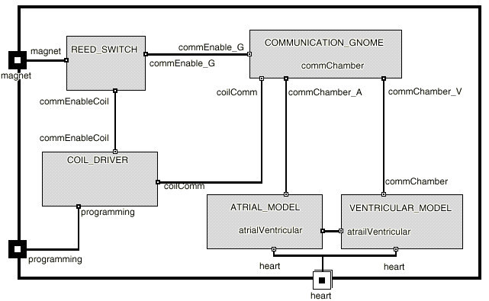

Figure 6 Actor diagram for the Pacemaker Example
Communication_Gnome (CG): Receives bytes from the coil driver, verifies these bytes as commands, and sends the commands to the Ventricular and Atrial models. It sends the positive and negative acknowledgments to the coil driver to verify command processing.
Ventricular_Model (VT) and Atrial_Model (AR): These two actors are similar in operation. They both could pace the heart and/or sense heartbeats. The AVI mode, chosen to be simulated, is a complicated mode as it requires coordination between the Atrial and Ventricular models. Once the Pacemaker is programmed the magnet is removed from the Reed_Switch. The Atrial_Model and Ventricular_Model communicate together without further intervention. Only battery decay or some medical maintenance reasons force reprogramming.
The behavior of each of the actors is modeled by a ROOMchart, which is based on statechart notation and semantics [Harel87]. Due to space limitations, we have included selected ROOMcharts for some actors in appendix A.
As mentioned earlier, a Pacemaker can be programmed to operate in one of several modes depending on which part of the heart is to be sensed and which part is to be paced. The analysis of the device operation defines several scenarios. We limit our discussion to two scenarios. The first is Programming scenario in which the programmer sets the operation mode of the device. The programmer applies a magnet to enable communication with the device, then he sends pulses to the device which in turn interprets these pulses into programming bits. The device then send back the data to acknowledge valid/invalid program.
The second scenario is the AVI_Operation scenario. In this scenario, the Ventricular_Model monitors the heart. When a heart beat is not sensed, the Artial_Model paces the heart and a refractory period is then in effect.
The sequence diagrams for the two scenario are shown in appendix B. The programming scenario is executed less frequently than any operation scenario because the device is only programmed during maintenance periods which could be several months. Operation scenarios are triggered every heartbeat period of time.

Dynamic Coupling Metrics
Based on the two metrics IOC and EOC defined in Section 4, we use the simulation reports to gather the statistics for each actor in the system. We use the coupling matrix-approach [Yacoub+99] to explore dynamic coupling between the objects. The cell value of the coupling matrix indicates the import coupling measurement of the actor in the cell's row with respect to the actor in the corresponding column.
Table 1 shows the dynamic coupling matrix for the Programming scenario as average percentages of the total number of messages sent in several simulation runs.
 | RS | CD | CG | AR | VT | Heart | Progammer
RS |  | 0 | 0 |  |  |  | 8.3
CD | 8.3 |  | 12.5 |  |  |  | 29.3
CG | 8.3 | 16.7 |  | 0 | 0
AR |  |  | 8.3 |  | 0 | 0
VT |  |  | 8.3 | 0 |  | 0
Table 1 Dynamic coupling for the Programming scenario in percentage (%)
Table 2 shows the dynamic coupling matrix for the AVI_Operation scenario as percentage of the total number of messages sent in several AVI_Operation scenario simulation runs.
 | RS | CD | CG | AR | VT | Heart | Prog.ammer
RS |  | 0 | 0 |  |  |  | 0
CD | 0 |  | 0 |  |  |  | 0
CG | 0 | 0 |  | 0 | 0
AR |  |  | 0 |  | 37.9 | 0
VT |  |  | 0 | 22.4 |  | 28.5
Heart |  |  |  | 11.2
Table 2 Dynamic Coupling for the AVI_Operation scenario as percentages (%)
Table 3 shows the dynamic coupling for the system based on (0.01,0.99) scenario probabilities for Programming and AVI_Operation respectively.

 | RS | CD | CG | AR | VT
IOC | 0.08 | 0.5 | 0.25 | 42.35 | 56.82
EOC | 0.27 | 0.27 | 0.46 | 53.53 | 45.47
Table 3 Dynamic Coupling for the Pacemaker

Dynamic Complexity Metrics
Using the dynamic complexity metrics defined in Section 5, we gather statistics from the simulation of the two selected scenarios. Figure 10 shows the dynamic complexity (as percentiles) for the Programming scenario, the AVI_Operation scenario, and the dynamic complexity of the system based on (0.01/0.99) scenario probabilities.

Cpx for Scenario | RS | CD | CG | AR | VT
Programming | 6.5 | 65.5 | 28 | 0 | 0
AVI | 0 | 0 | 0 | 42.8 | 57.2
Overall | 0.065 | 0.655 | 0.28 | 42.4 | 56.6
Table 4 Dynamic Complexity Metrics for the Pacemaker as Percentages (%)

CBO and NAS
The following table shows the CBO and NAS static metrics for the Pacemaker based on the actor diagram shown in Figure 6 and the number of invocations in the ROOM execution models.

 | RS | CD | CG | AR | VT
NAS | 18.75 | 18.75 | 25 | 18.75 | 18.75
CBO | 13.5 | 23.1 | 28.8 | 17.3 | 17.3
Table 5 NAS and CBO for the Pacemaker as percentages

Results
- From table 5 first row, we conclude that the coupling metric NAS cannot give a distinct indication of coupling levels in the system because the actors have NAS coupling levels that are close to each other except for the Communication_Gnome which is little bit higher.
- From table 5 second row, the coupling metric CBO gives an indication that the Communication_Gnome and the Coil_Driver are the most coupled actors followed by the Atrial_Model and Ventricular_Model. This conclusion is based on a static metric , which does not consider the dynamic activities and frequency of messages between actors in the system.
- From table 3, the dynamic coupling metrics IOC and EOC indicate that the Atrial_Model and Ventricular_Model are the most coupled actors and coupling of other actors is not significant. This is because these two actors are the most active as they control the operational processing of the system. Hence, dynamic coupling metrics identified actors with the highest run-time coupling.
- From table 4, we conclude that the dynamic complexity of the actors Atrial_Model and Ventricular_Model are significantly higher than those for other actors. This is due to the fact that those two actors are active and executing most of the simulation time.
Static metrics, as applied to this example, either do not show ranks for coupling levels (NAS), or has identified coupling level based on static non-executing models (CBO). On the other hand, results from applying the proposed dynamic metrics have identified that the two objects Atrial_Model and Ventricular_Model are the most run-time coupled objects. As of dynamic complexity, the same two models are identified to be the most dynamically complex objects
As a result, we conclude that static and dynamic metrics can give different indications on the coupling and complexity of design elements. Dynamic metrics are concerned with frequently invoked and frequently executing objects while static metrics are concerned with statically coupled and complex design elements. Both metrics can give different indication on the quality of the design and empirical studies are essential to correlate each to errors found when the application is actually executing.

Conclusion
This paper augments existing literature on assessing the quality of object oriented designs by proposing a set of dynamic metrics as important supplements to existing static metrics. We define two metrics for object coupling (Import Object Coupling and Export Object Coupling) and operational complexity based on statecharts as dynamic complexity metrics. Measurements using the proposed metrics can be obtained at early development phases from executable design models. The metrics are applied to a case study and measurements are used to compare static and dynamic metrics. We envisage that dynamic metrics are as important as static metrics for evaluating design quality and identify the need for empirical studies to assess the correlation between dynamic metrics and faulty modules.
From this work we conclude the following:
- Dynamic metrics can be used to measure the actual run-time properties of an application as compared to the expected properties measured by static metrics.
- To use the proposed dynamic metrics early in the development phase, the application has to be modeled as executable designs. The excess effort in developing executable designs is justifiable for many complex real-time applications where deadlines should be investigated prior to developing the application.
- The proposed metrics do not reflect the complexity or coupling to abstract classes. It is applicable to concrete classes from which objects are executing at run-time.
- Two phases are important for establishing a metric for dynamic quality. The first is defining metrics, differentiating them from exiting metrics, and identifying the need for these metrics. The second phase is using empirically studies to validate the metric. This paper addresses the first phase and identifies the need for the empirical studies to explore the correlation between dynamic metrics and design quality in one hand and dynamic and static metrics on the other hand.
Future Work
- Explore the dependency between static and dynamic metrics. Objects are executable versions of the design, classes are the maintainable version. A correlation can exist between dynamic and static metrics.
- Empirically validate the proposed metrics and their correlation with design quality.

References
[Ammar+97] Ammar, H. H., T. Nikzadeh, and J. Dugan, "A Methodology for Risk Assessment of Functional Specification of Software Systems Using Coherent Petri Nets", Proc. Of the Fourth International Software Metrics Symposium, Metrics'97, Albuquerque, New Mexico, Nov 5-7, 1997, pp108-117
[Briand+95] Briand, L., K. El Emam, and S. Morasca, "Theoretical and Empirical Validation of Software Product Measures", Fraunhofer International Software Engineering Research, 1995, TR# ISERN-95-03
[Briand+97] Briand, L., P. Devanbu, and W. Melo, "An Investigation into Coupling Measures for C++," Proc. Of the 19th Int'l Conference on Software Engineering, ICSE'97, Boston, May 1997, pp 412-421
[Briand+98] Briand, L., S. Morasca, V. Basili, "Defining and Validating Measures for Object-based High-level Design ", Fraunhofer International Software Engineering Research, Germany 1998, ISERN-98-04
[Briand+99] Briand, L., J. Daly, and J. Wurst, “A Unified Framework for Coupling Measurement in Object-Oriented Systems”, IEEE Transaction on Software Engineering, Vol 25, No. 1, Jan/Feb 1999, pp91-121
[Chidamber+94] Chidamber, S. , and C. Kemerer, "A Metrics Suite for Object Oriented Design ", IEEE Transactions on Software Engineering, Vol 20, No 6, June 1994, pp476-493
[Douglass98] Douglass, B., "Real-Time UML : Developing Efficient Objects for Embedded Systems", Addison-Wesley, 1998
[Eder+94] Eder, J., G. Kappel, and M. Schrefl, "Coupling and Cohesion in Object-Oriented Systems," Technical Report, University of Klagenfurt, 1994, ftp://ftp.ifs.uni-linz.ac.at/pub/publications/1993/0293.ps.gz
[Fenton91] Fenton, N., "Software Metrics: A Rigorous Approach", London, Chapman&Hall, 1991
[Fenton94] Fenton, N., "Software Measurement: A necessary Scientific Basis", IEEE Transaction on Software Engineering Vol 20, No 3, March 1994, pp199-206
[Gamma+95] Gamma, E., R. Helm, R. Johnson, and J. Vlissides, "Design Patterns: Elements of Object-Oriented Software", Addison-Wesley, 1995.
[Harel87] Harel, D., "Statecharts: A Visual Formalism for Complex Systems", Science of Computer Programming, July 1987, pp231-274
[Harrison+98] Harrison, R., S. Counsell, and R. Nithi, "Coupling Metrics for Object Oriented Design", Proc. Of the fifth Metrics Symposium, Bethesda, Maryland, Nov 20-21, 1998, pp150-157
[Hitz+95a] Hitz, M., and B. Montazeri. "Measuring Coupling and Cohesion in Object-oriented Systems", in Proc. Intl. Symposium on Applied Corporate Computing, Monterrey, Mexico, Oct. 1995.
[Hitz+95b] Hitz, M., and B. Montazeri "Measuring Product Attributes of Object-Oriented Systems", in Proc. 5th European Software Engineering Conference (ESEC `95). Barcelona, Spain: Lecture Notes in Computer Science 989, Springer-Verlag 1995, pp124-136
[Hitz+96] Hitz, M., and B. Montazeri; "Chidamber & Kemerer's Metrics Suite, A Measurement Theory Perspective", IEEE Transactions on Software Engineering, Vol 22, No. 4, April 1996, pp276-270
[Khoshgoftaar+93] Khoshgoftaar, T. M., J. C. Munson, and D.L. Lanning,"Dynamic System Complexity", Proc. Of International Software Metrics Symposium, Metrics'93, Baltimore MD., May 1993, pp129-140
[Lee+95] Lee, Y., B. Liang, and S. Wu, "Measuring the Coupling and Cohesion of an Object-Oriented Program Based on Information Flow," Proc. Of International Conference on Software Quality, Maribor, Slovenia, 1995
[Li+93a] Li, W., and S. Henry, “Object Oriented Metrics that predict Maintainability” Journal of Systems and Software, Vol 23, no. 2, 1993, pp 111-122
[Li+93b] Li, W., and S. Henry, “Maintenance Metrics that for the Object Oriented Paradigm” Proc. Of 1st Int'l Software Metrics Symposium, Los Alamitos, CA, 1993, pp52-60
[McCabe76] McCabe, T., "A Complexity Metrics", IEEE Trans on Software Engineering, Vol 2, No. 4, Dec 1976, pp308-320
[Munson+96] Munson, J., and T. Khoshgoftaar, "Software Metrics for Reliability Assessment", in Handbook of Software Reliability Engineering, Michael Lyu (edt.), McGraw-Hill, 1996, Chapter 12, pp 493-529
[ObjecTime98] ObjecTime User Guide. ObjecTime Ltd., Kanata, Ontario, Canada, 1998.
[Selic+94] Selic, B., G. Gullekson, and P. Ward, “Real-Time Object Oriented Modeling”, John Wiley & Sons, Inc. 1994
[UML99] The Unified Modeling Language Resource Center http://www.rational.com/uml/ index.html
[Yacoub+99] Yacoub, S., and H. Ammar, "A Matrix-Based Approach to Measure Coupling in Object-Oriented Designs", to appear in Journal of Object Oriented Programming, JOOP, 1999

Appendix A : ROOMcharts for some Selected Actors
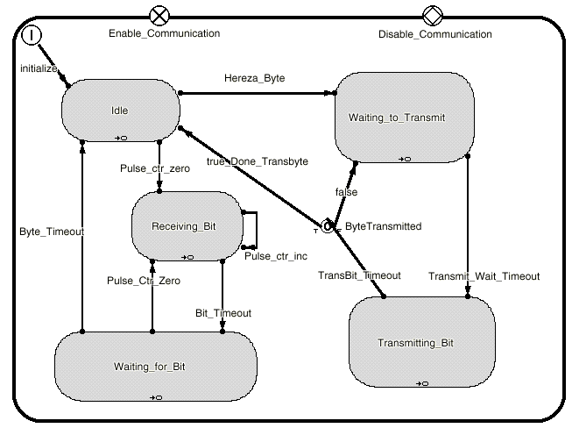

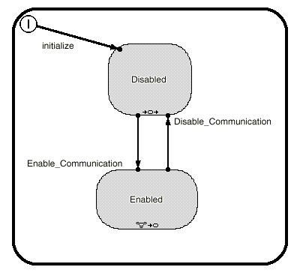
Coil Driver

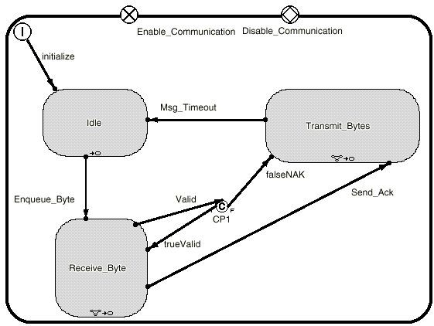
Communication Gnome
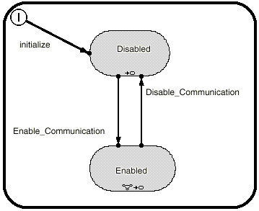

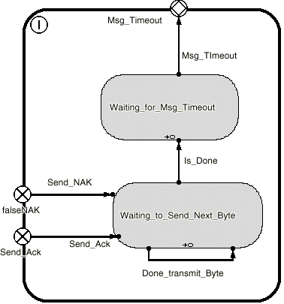
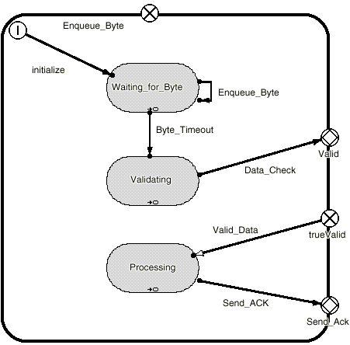

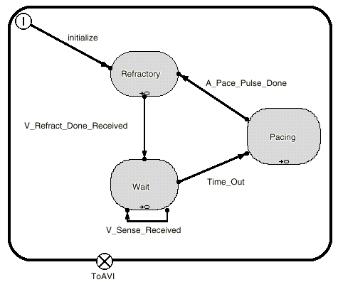
Atrial Model

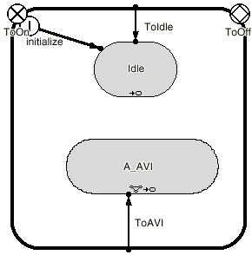
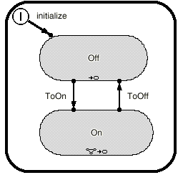

Appendix B: Sequence Diagram for Programming and AVI_Operation Scenarios

AVI_Operation Scenario

Programming Scenario

For the rest of the paper, we refer to an interaction between two objects as a message. Object interaction can be a method call, invocation or a message sent across a link.
The same idea is not only applicable to criticality but also maintenance, understandability, and other attributes.

